Name SURNAME (11 pt.)

TITLE OF PAPER (16 pt.)

- Introduction (12 pt.)
Text of introduction, text of introduction, text of introduction, text of introduction, text of introduction, text of introduction, text of introduction, text of introduction, text of introduction, text of introduction (12 pt.)

2. Title of chapter (12 pt.)
The main text. The main text. The main text. The main text. The main text. The main text. The main text. The main text. (12 pt.)
The main text. The main text. The main text. The main text. The main text. The main text. The main text. The main text. References in text should have this form [surname, & surname, year], for example: [Kaplan, &Anderson, 2013].

Tab. 1: Title of table (10 pt.)
10 pt. Times New Roman
10 pt. Times New Roman
Source: xxxxxxxxxxxxx (10 pt.)

The main text. The main text. The main text. The main text. The main text. The main text. The main text. The main text. The main text. The main text. The main text. The main text. References in text should have this form [surname, year], for example: (Kaplan, & Norton, 1996).

3. Title of chapter (12 pt.)
The main text. The main text. The main text. The main text. The main text. The main text. The main text. The main text:
- text, text, text, text, text, text, text, text, text, text, text, text, text, text, text, text, text, text, text, text, text;
- text, text, text, text, text, text, text, text, text, text, text, text, text, text, text, text, text, text, text, text, text.
Fig. 1: Title of figure (10 pt.)
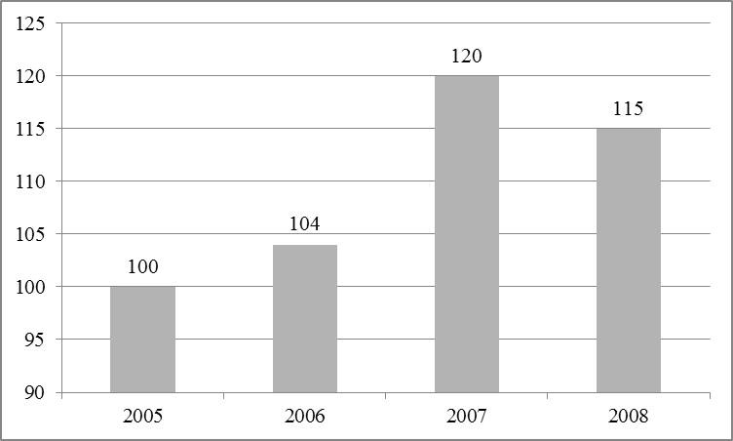
Source: xxxxxxxxxxxxx (10 pt.)

3. Conclusion (12 pt.)
The main text. The main text. The main text. The main text. The main text. The main text. The main text. The main text. (12 pt.)

References (12 pt.)
All citations in the text and all references must meet APA styles (American Psychological Association – more information http://www.apastyle.org/) (10 pt.)

- Archibugi, D., & Lundvall, B. Å. (2002). The globalizing learning economy. Oxford University Press.
- Drury C., (2008) Management and cost accounting, 7th edition, Cengage Learning;
- Kaplan, R. S., & Norton, D. P. (1996). The balanced scorecard: translating strategy into action. Harvard Business Press.
- Kaplan, R. S., & Norton, D. P. (1995). Putting the balanced scorecard to work. Performance measurement, management, and appraisal sourcebook, 66.

Name SURNAME (9 pkt.)

TITLE OF THE PAPER (10 pkt.)

(Summary) (9 pkt.)
Text of the summary.

 Author's affiliation (9 pkt.)
Footnote.

